Regular meet – Wednesday 5:30pm

To Do’s

* Make webpage
* Clean data -> extract only what we need
* Write up a problem statement/Introduction about our migration issue

Repo created and shared with both group members

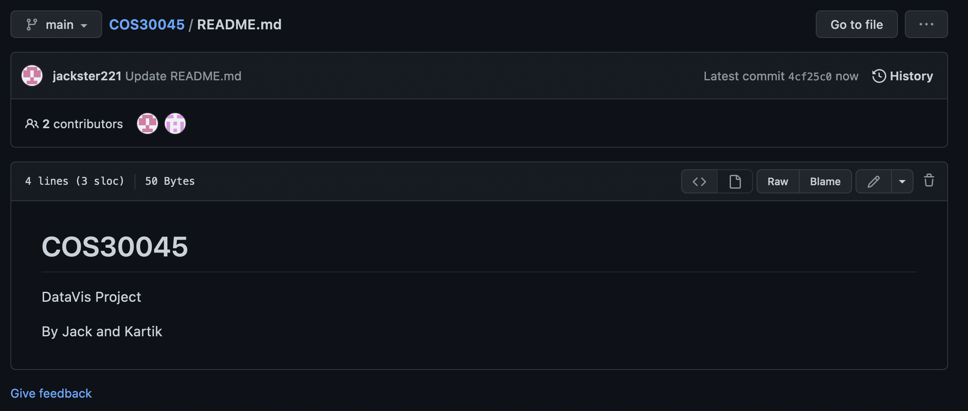

Discord created for communication

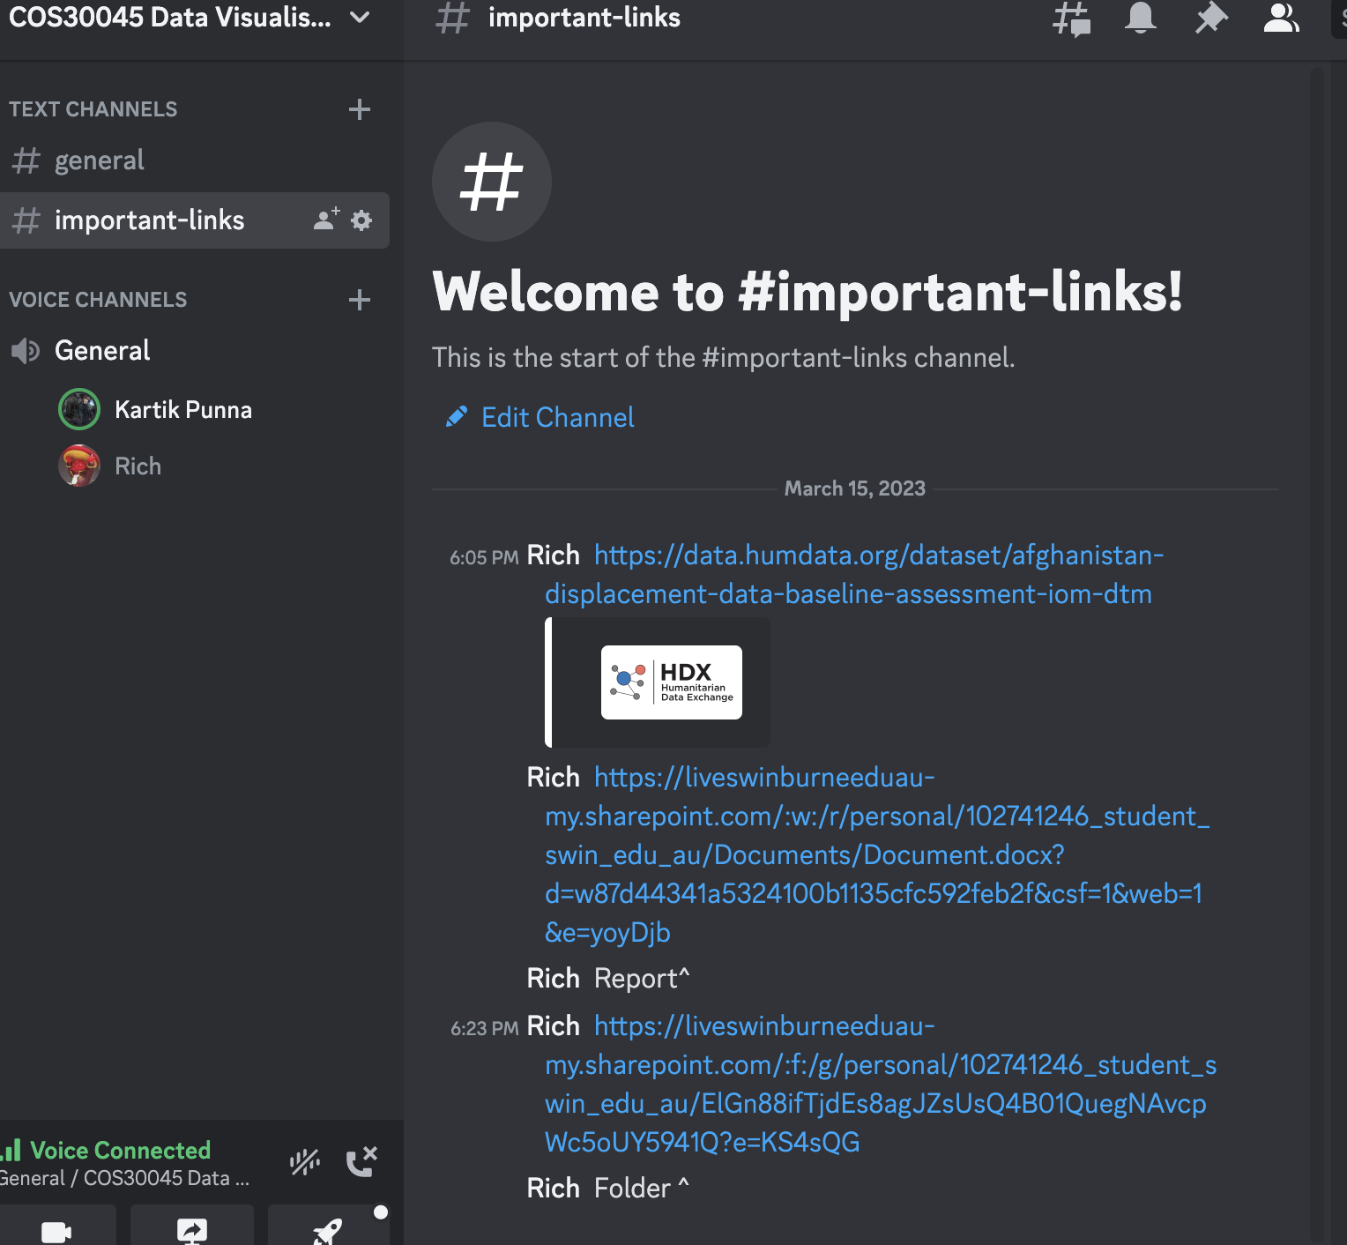

One drive folder created and shared between both members

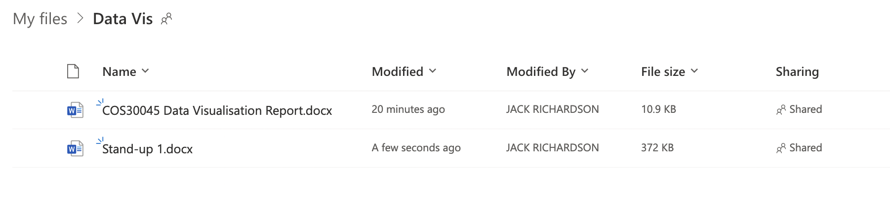

Schedule

Week 1-3

* Select migration topic
* Find dataset
* Extract relevant data from dataset in accordance with migration topic and questions

Week 4 – 7

* Develop web page
* Clean dataset
* Build charts/graphs from data
* Begin writing report

Week 8 – 12

* Polish web page and graphs
* Finish report

No teamwork issues

References:

Data Source: <https://data.humdata.org/dataset/afghanistan-displacement-data-baseline-assessment-iom-dtm>

IDP = Internally displayed people